SU Pay Instructions
I am a student. How do I login?

Students: Go to www.suffolk.edu/payment
- Login to your MySuffolk/Campus Cruiser account using your portal username and password.
- Go to the My Finances tab, and click on View Your Student Account.
- On the View Your Student Account page, click on the large button named View & Pay your student account.
- Clicking on this button takes you to Suffolk’s SU Pay –Billing & Payment Gateway.

I have been set up as an Authorized user? How do I login?

Authorized User Access: Authorized users enter the system through the same webpage,
www.suffolk.edu/payment and use the Authorized Users section. Please use the login information you received when your student set you up as an authorized user in SU Pay. You will receive two emails with the login information.

The same screens are viewable by the authorized user as well as the student. If an authorized user makes a payment, both parties are notified that a payment was made.

How do I set up an authorized user?

You can set up an authorized user to view your account, tuition statements, and make payments on your behalf. Login to SU PAY as instructed above. Select Authorized Users located under My Account.

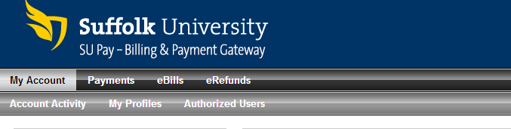

Enter the email address of the individual you would like to add as an authorized user. Your authorized user will receive two emails with login information to access the system.

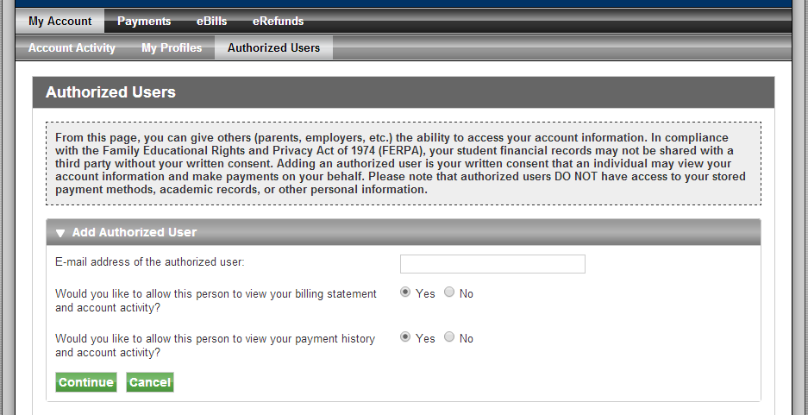

The same screens are viewable by the authorized user as well as the student. If an authorized user makes a payment, both parties are notified that a payment was made. Payment information (account numbers, etc.) will never be shared. Whenever a new bill is loaded, both you and your authorized user will receive an email and be able to view the bill. You may set up numerous individuals as authorized users (parents, guardians, grandparents, etc.).

How do I view my bill?

Go to eBills to review your current bill.
The summary at the top reflects your most current billing statement. Using the drop down box you can select new statements as they become available.

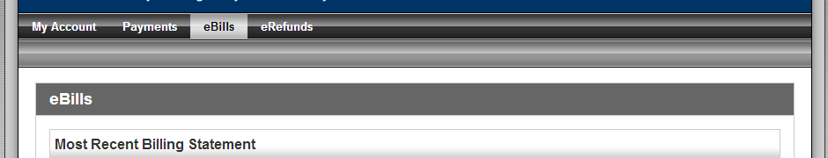

How do I make a payment?

Under the Payments tab select Account Payment and choose the Make a Payment button. You will also be able to see any scheduled payments that you may have set up for a future date.

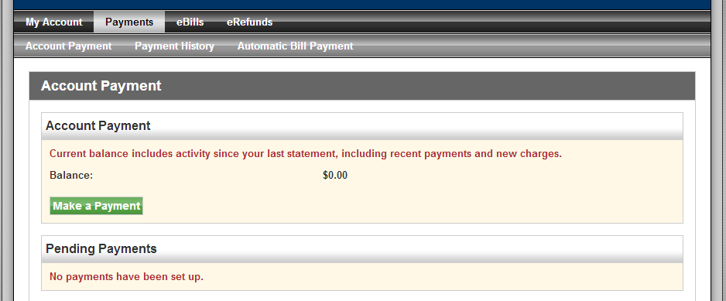

Follow the instructions on the payment pages to complete your payment. Once you agree to make the payment you will receive a payment confirmation and an email notification. If an authorized user makes a payment on your behalf, the authorized user will also receive an email confirmation of the payment. Please check your email(s) to verify that confirmation was received.

What is eRefunds? What do I have to do?
eRefunds is an electronic option for you to receive your refunds directly to a bank account set up by you. Please remember refunds can be set up to go to a bank but not to a credit card. When setting up eRefunds, please make sure to consult with your authorized user, if you have one, so that both of you are in agreement of the refund being sent directly to the bank. Once eRefunds is set up, unless requested, no paper checks will be issued as refunds.

