INSTRUCTIONS FOR COMPLETING THE FNIF FORM

Complete all fields on the first page of the Foreign National Information Form (FNIF)
For Visa status of J, include a DS-2019 (example below)
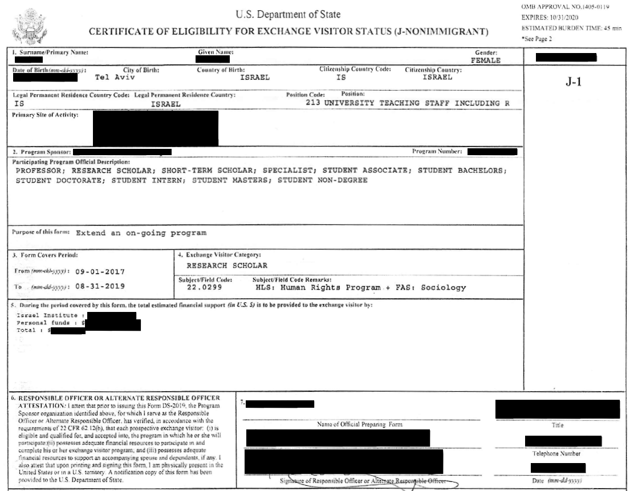
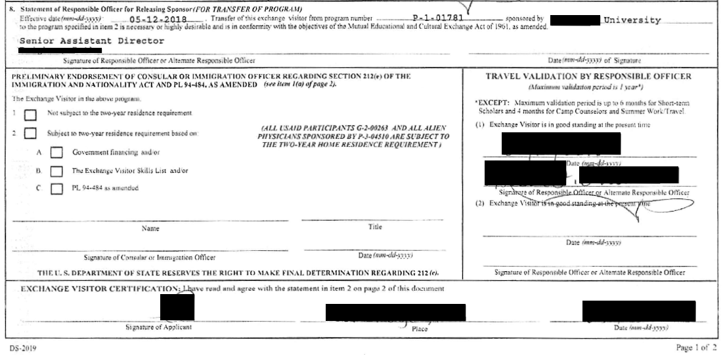
For question 23 on the 2nd page
- Follow the link in the instructions on the form to the web-site
- Click on View Travel History
- Click Consent & Continue
- Enter your information
- Click Next
- Continue until you are on a screen as shown below
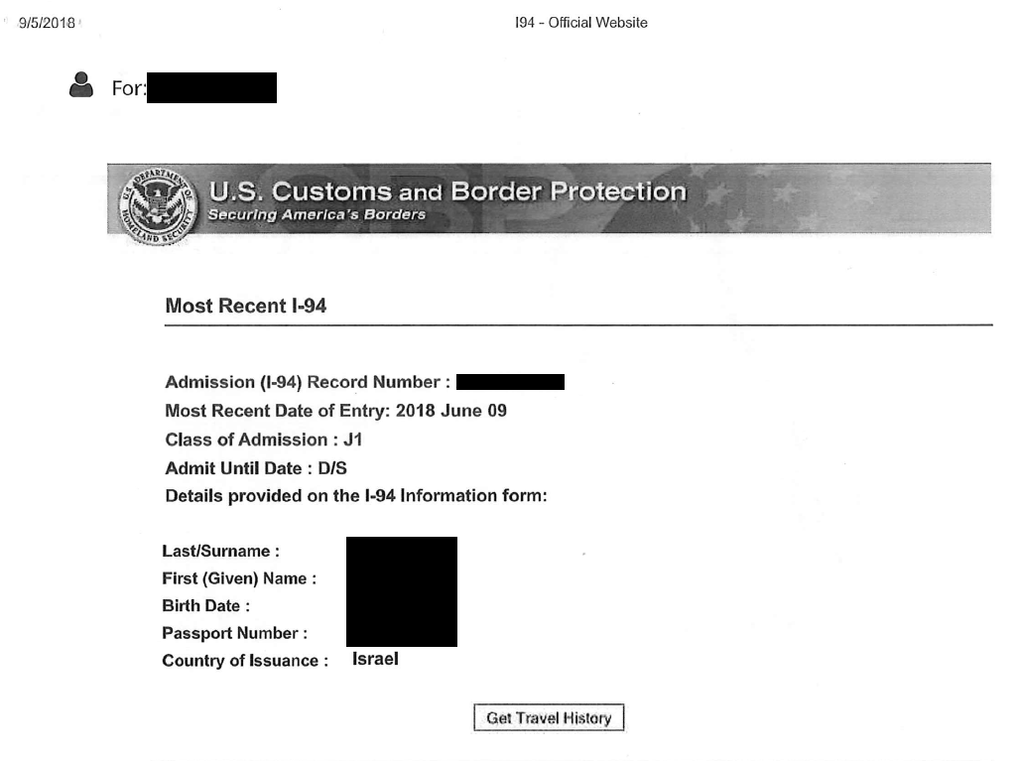
- Click on Get Travel History
- Continue until you are on a screen a shown below
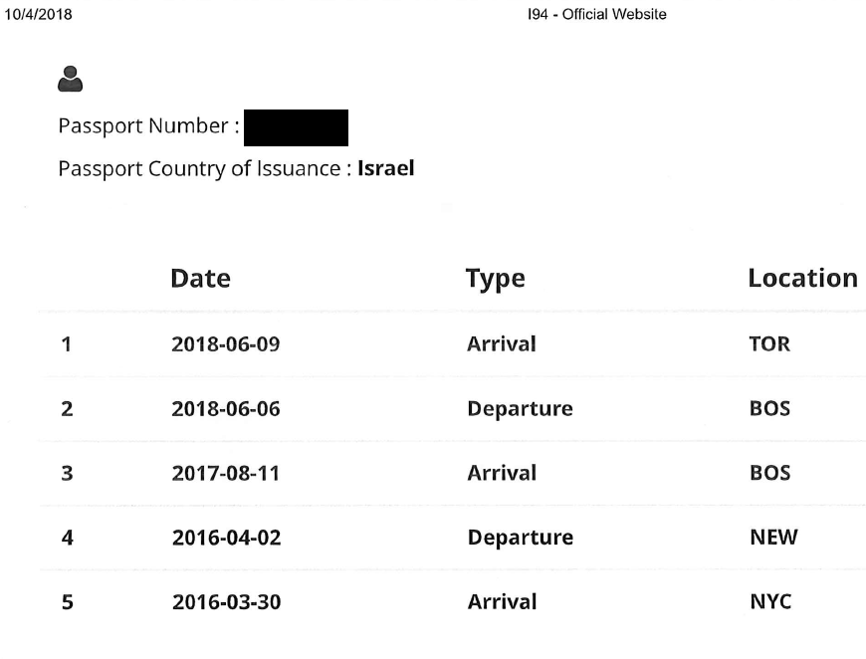
- This will assist you in completing question 23 on the FNIF form. Include these printouts when submitting your FNIF.

