Download the OneDrive App to your local machine.
You will see a OneDRive icon
Listed in your File folder
Login to o365.suffolk.edu
Click on App launcher (top left cube of dots)

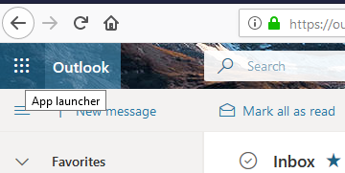

Choose OneDrive

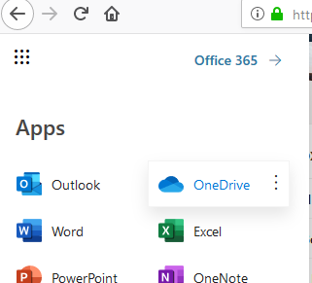

On the bottom Left column, choose Get the OneDrive Apps
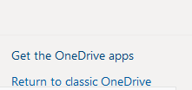
This will download the installer – you will need to run the installer and login with your Suffolk credentials.

